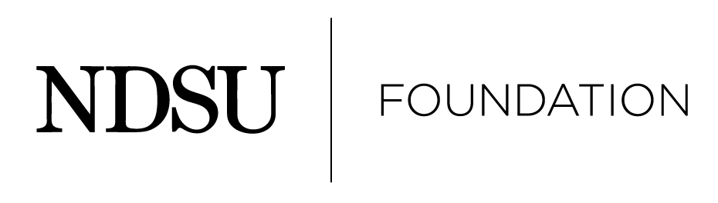

2026 NDSU Partner in Excellence Award

Nomination Form
Introduction

The Foundation places an emphasis on recognizing a corporation, foundation or organization that has given outstanding and significant support as well as demonstrated inspirational philanthropic giving to the university.

This includes recruitment of interns and graduates, participation in lectures and seminars, intellectual exchanges, research alliances, employees or members actively engaged with the University on advisory boards, councils or university affiliated organizations.

The following criteria for the Partner in Excellence Award have been established by the NDSU Foundation:

Eligibility
- The organization must have demonstrated partnership and support in one of the following ways with the university.
  - Recruitment of interns and graduates.
  - Participation in lectures and seminars.
  - Share intellectual exchanges and research alliances.
  - Employees or members actively engaged on advisory boards, council or university affiliated organizations.
  - Demonstrate inspirational philanthropic giving.
2. The reputation of the organization should reflect favorably on North Dakota State University.

Nomination Process
- Anyone is eligible to submit a nomination packet for another individual. Self nominations are not accepted.

2. Instructions to nominator:
- Be sure to keep a copy of all materials submitted for personal future reference.

- Submit only the original packet material. There is no need to provide multiple copies of the nomination packet.

- Please do not place nomination papers in a binder. Please keep items in an 8 ½ x 11, one-sided format that is easy to copy.

3. The following criteria are required:
  - A completed nomination form.

  - A one-page summary of organization’s involvement including two references who can speak to the nomination. One reference should be a NDSU administrator, faculty or staff member.

Notification Process

1. The NDSU Alumni Awards Committee made up of Foundation trustees and university deans will select recipients.

2. When the recipients have been selected, they will be notified by an NDSU Foundation representative. Nominators will be notified once recipients have accepted.

3. Nominations submitted, but not selected, will be kept on file to be considered for two additional years. Updated nominee information is encouraged.
Submission Procedures

A complete nomination packet will include the following, please check that the required items are enclosed:

- The completed nomination form.

- A one-page summary of the organization’s involvement along with contact information for two references.

Please send completed nominations by August 4, 2025, to:

Alumni Awards Committee
NDSU Foundation
1241 University Drive North
Fargo, ND 58102
800-279-8971
Fax (701) 231-6801
office@ndsufoundation.com

Thank you for your nomination!

Please remember: Nominations are not relayed to the nominee until the NDSU Foundation has acted.

2026 NDSU Partner in Excellence Award

Nomination Form

Please print the following information:

Name of Organization:

Organization Contact:

Address:

Daytime telephone:

E-Mail:

Nominated by:

Nominator’s E-Mail:

Nominator’s Daytime Telephone:

A complete nomination packet will include the following, please check that the required items are enclosed:

- The completed nomination form.

- A one-page summary of the organization’s involvement along with contact information for two references.

Please send completed nominations by August 4, 2025 to:

Alumni Awards Committee
NDSU Foundation
1241 University Drive North
Fargo, ND 58102
800-279-8971
Fax (701) 231-6801
office@ndsufoundation.com

