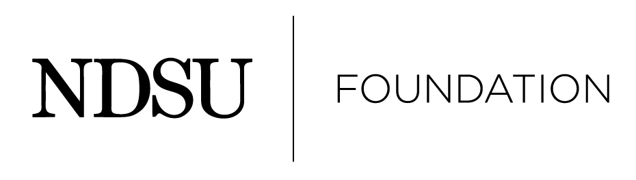

2026 NDSU Henry L. Bolley Academic Achievement Award Nomination Information

Introduction

This award was established to recognize the achievements of alumni who work in education as teachers, researchers and/or administrators.

Alumni will be considered for both their accomplishments in their academic field and service to their alma mater.

Through the awards program, the NDSU Foundation expresses its pride and appreciation for these individuals and their service to teaching, enhancing educational opportunities and expanding research to better our world. It focuses attention not only on these outstanding persons and their accomplishments, but also on the vital relationship between alumni and the university in promoting education and enhancing society through research and academic excellence.

The award recipient will be invited to return to NDSU to present one or more formal presentations. There may also be events with current students, faculty and community leaders scheduled around the recipient’s visit.

Eligibility

1. NDSU alumni who are graduates are eligible to receive the award.

2. Current NDSU faculty and staff are not eligible.

3. There will be no posthumous awards.

Nomination Process
1. Anyone is eligible to submit a nomination packet for another individual. Self nominations are
not accepted.

2. Instructions to nominator:
- Be sure to keep a copy of all materials submitted for personal future reference.

- Submit only the original packet material. There is no need to provide multiple copies of the nomination packet.

- Please do not place nomination papers in a binder. Please keep items in an 8 ½ x 11, one-sided format that is easy to copy.

3. The following criteria are required:
  - A completed nomination form.

  - A letter from the nominator noting at least three (3) specific reasons for the nominee to be considered.

Nomination Process continued

  - Three (3) additional letters supporting the nomination. (If more than three letters are received, the first three (3) letters received will be placed in the nomination folder.) Please be sure all support letter writers include their address and contact information.

All support letter writers will be notified if their nominee is chosen as a recipient.

  - A detailed vita/résumé listing awards, accomplishments, education, etc.

  - A one-page summary of the vita/résumé including outstanding contributions and facts that you want the Selection Committee to specifically note.

Notification Process

1. A committee made up of Foundation trustees and university deans will select recipients.

2. When the recipients have been selected, they will be notified by a NDSU Foundation representative. Nominators will be notified once all recipients have been notified.

3. Nominations submitted, but not selected, will be kept on file to be considered for two additional years. Updated nominee information is encouraged.

Submission Procedures

A complete nomination packet will include the following, please check that the required items are enclosed:

- The completed nomination form.
- Nomination letter noting at least three (3) specific reasons for the nominee to be considered.
- No more than three (3) additional letters supporting the nomination.
- A detailed vita/résumé listing awards, accomplishments, education, etc.
- A one-page summary of the vita/résumé including outstanding contributions and facts that you want the Selection Committee to specifically note.

Please send completed nominations by August 4, 2025 to:

Alumni Awards Committee
NDSU Foundation
1241 University Drive North
Fargo, ND 58102
800-279-8971
Fax (701) 231-6801
office@ndsufoundation.com

Thank you for your nomination!

Please remember: Nominations are not relayed to the nominee until the NDSU Foundation has acted.

2026 NDSU Henry L. Bolley Academic Achievement Award Nomination Information

Please print the following information:

Name of Candidate:

Address:

Daytime telephone:

E-Mail:

Year of graduation:

Nominated by:

Nominator’s E-Mail:

Nominator’s Daytime Telephone:

A complete nomination packet will include the following, please check that the required items are enclosed:

- The completed nomination form.
- Nomination letter noting at least three (3) specific reasons for the nominee to be considered.
- No more than three (3) additional letters supporting the nomination; contact the NDSU Foundation if you need assistance to secure letters
- A detailed vita/résumé listing awards, accomplishments, education, etc.
- A one-page summary of the vita/résumé including outstanding contributions and facts that you want the Selection Committee to specifically note.

Please send completed nominations by August 4, 2025 to:

Alumni Awards Committee
NDSU Foundation
1241 University Drive North
Fargo, ND 58102
800-279-8971
Fax (701) 231-6801
office@ndsufoundation.com

