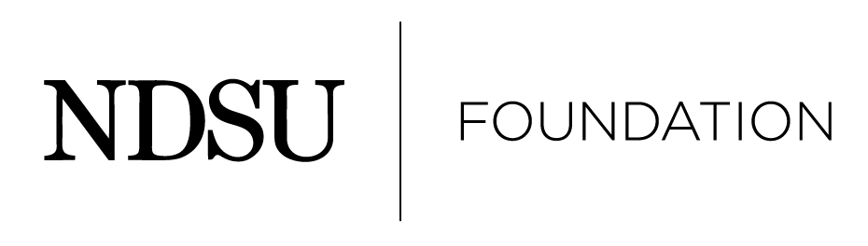

2026 NDSU Alumni Achievement Award

Nomination Information

Introduction

The Foundation places an emphasis on the recognition of individuals who have distinguished themselves in their professional fields.

The following criteria for the Alumni Achievement Award have been established by the NDSU Foundation:

Eligibility
- NDSU alumni who are graduates are eligible to receive the award.
- Current NDSU faculty and staff are not eligible.

3. There will be no posthumous awards.

4. The candidate must have achieved a level of distinction which would merit comparable recognition in his/her profession or area of excellence.
5. The reputation of the candidate should reflect favorably on North Dakota State University.

Nomination Process
1. Anyone is eligible to submit a nomination packet for another individual. Self nominations are
not accepted.

2. Instructions to nominator:
- Be sure to keep a copy of all materials submitted for personal future reference.

- Submit only the original packet material. There is no need to provide multiple copies of the nomination packet.

- Please do not place nomination papers in a binder. Please keep items in an 8 ½ x 11, one-sided format that is easy to copy.

3. The following criteria are required:
  - A completed nomination form.

  - A letter from the nominator noting at least three (3) specific reasons for the nominee to be considered.

  - Three (3) additional letters supporting the nomination. (If more than three letters are received, the first three (3) letters received will be placed in the nomination folder.) Please be sure all support letter writers include their address and contact information. All support letter writers will be notified if their nominee is chosen as a recipient.

  - A detailed vita/résumé listing awards, accomplishments, education, etc.

  - A one-page summary of the vita/résumé including outstanding contributions and facts that you want the Selection Committee to specifically note.

Notification Process
    - A committee made up of Foundation trustees and university deans will select recipients.

- When the recipients have been selected, they will be notified by a NDSU Foundation representative. Nominators will be notified once all recipients have accepted.

3. Nominations submitted, but not selected, will be kept on file to be considered for two additional years. Updated nominee information is encouraged.

Submission Procedures

A complete nomination packet will include the following, please check that the required items are enclosed:

- The completed nomination form
- Nomination letter noting at least three (3) specific reasons for the nominee to be considered
- No more than three (3) additional letters supporting the nomination
- A detailed vita/résumé listing awards, accomplishments, education, etc.
- A one-page summary of the vita/résumé including outstanding contributions and facts that you want the Selection Committee to specifically note

Please send completed nominations by August 4, 2025 to:
Alumni Awards Committee
NDSU Foundation
1241 University Drive North
Fargo, ND 58102
800-279-8971
Fax (701) 231-6801
office@ndsufoundation.com

Thank you for your nomination.

Please remember: Nominations are not relayed to the nominee until the NDSU Foundation has acted.

2026 NDSU Alumni Achievement Award

Nomination Information

Please print the following information:

Name of Candidate:

Address:

Daytime telephone:

E-Mail:

Year of graduation:

Nominated by:

Nominator’s E-Mail:

Nominator’s Daytime Telephone:

A complete nomination packet will include the following, please check that the required items are enclosed:

- The completed nomination form
- Nomination letter noting at least three (3) specific reasons for the nominee to be considered.
- No more than three (3) additional letters supporting the nomination; contact the NDSU Foundation if you need assistance to secure letters
- A detailed vita/résumé listing awards, accomplishments, education, etc.
- A one-page summary of the vita/résumé including outstanding contributions and facts that you want the Selection Committee to specifically note.

Please send completed nominations by August 4, 2025 to:
Alumni Awards Committee
NDSU Foundation
1241 University Drive North
Fargo, ND 58102
800-279-8971
Fax (701) 231-6801
office@ndsufoundation.com

